ARCHITECT REVIEW
SALDEV-1467 | Resolve Apex Error on Opportunity Line ID Flow
FlywirePartial | Read-only implementation review and check-only validation
Source | FlywirePartial | Sandbox org 00DhG0000000jOXUAY
Scope | 1 obsolete Flow | 3 triggers | 6 Apex classes/tests
Review date | 28 August 2026
Check-only | Failed | Job 0AfhG000001ZTplSAG | 10/10 components, 16/16 tests
Decision | NO-GO - Changes Requested before QA or promotion
Boundary | No records, deployment, activation, or org metadata were changed

ARCHITECT DECISION
Do not approve SALDEV-1467. The scoped package compiles and all specified tests pass, but check-only validation fails coverage gates and the replacement retains the original cross-object Quote Line DML risk from an OLI after-insert context.

Acceptance outcome
# | Scope | Result | Evidence
1 | Original Flow | Verified | copying_of_Opportunity_Line_Id_unique_identifier has status Obsolete in FlywirePartial.
2 | Stepped products | Partial | Mapping logic exists, but tests prove only non-null/fallback values rather than exact cross-group identity for all bundle slots.
3 | Price-change clone | Not proven | The amendment method is invoked, but no assertion confirms the cloned line retains the source Opportunity Line ID.
4 | Other clone | Not proven | No test proves an ordinary clone receives a new Opportunity Line ID or remains independent of the source line.
5 | New / Amend / Renew | Gap | Fixtures mention these contexts, but end-to-end cloning outcomes are not asserted for each lifecycle path.
6 | Error-free quoting | Blocked | Synthetic tests pass; no representative bundle test proves the CPQ async collision is eliminated.

Runtime-risk path
The obsolete Flow removes one writer, but the replacement OLI after-insert trigger still performs cross-object DML on SBQQ__QuoteLine__c and can re-enter CPQ after-update processing.
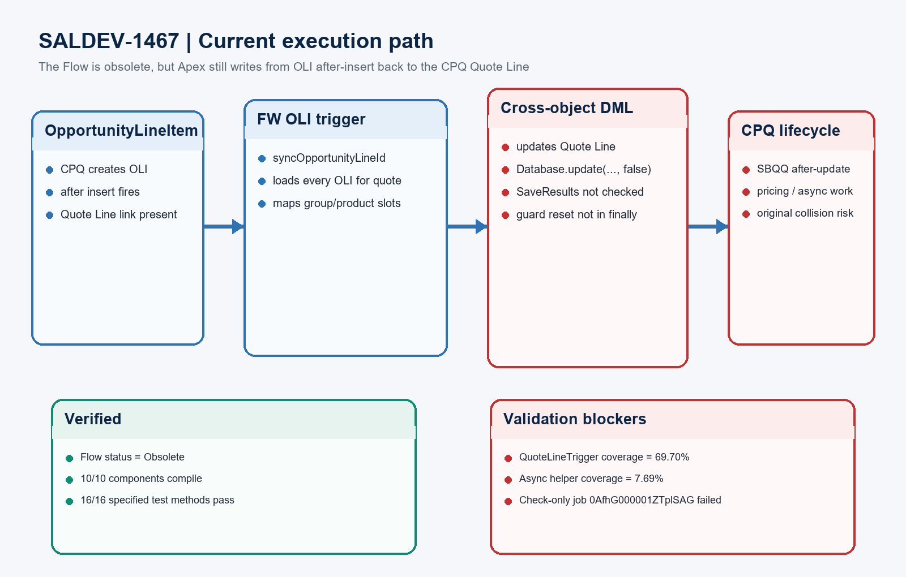
Figure 1. SALDEV-1467 current OLI-to-Quote-Line execution path
DESIGN READING
Green is verified. Amber needs stronger evidence. Red blocks approval or can recreate the original failure mode.

Detailed review findings

1. Check-only validation evidence
Metric | Result | Evidence
Validation job | Failed | 0AfhG000001ZTplSAG; checkOnly=true; rollbackOnError=true; no component or test errors.
Payload | 10 components | 1 Flow, 3 triggers, 6 Apex classes/tests; all 10 compiled successfully.
Specified tests | 16 passed | OpportunityLineItemTriggerHandlerTest (2), QuoteLineTriggerHandleTest (8), QuoteLineGroupTriggerTest (6).
Coverage gates | Failed | QuoteLineTrigger 69.70%; QuoteLineGroupAsyncHelper 7.69%; each selected component requires at least 75%.
Focused test run | Passed | Job 707hG00000LhjKT; 100% pass rate; org-wide coverage 30%.

2. Exact approval blockers
Blocker | Impact | Exact evidence
Deployment coverage | Hard fail | QuoteLineTrigger has 33 executable locations with 10 uncovered; helper has 13 with 12 uncovered.
Cross-object DML | Runtime risk | OLI after insert calls Database.update on Quote Lines, re-entering the managed SBQQ after-update lifecycle.
Silent failure handling | Data risk | Database.update(..., false) SaveResults are ignored; guard reset is not protected by finally.

3. Code and test-quality findings
Area | Status | Evidence / required action
Fallback overload | Defect | When relationship data is absent, processOliIdSync(List) adds Quote Line IDs to the quote-ID set; its test asserts only true.
Ramp key design | Risk | Before-insert mapping keys only quote plus product and uses ordered slots; repeated products in multiple bundles can be ambiguous.
Exception handling | Risk | copyOpportunityLineIdOnRamp catches all exceptions and only debugs, allowing quoting to continue with missing IDs.
Acceptance assertions | Missing | No exact ID equality/inequality assertions for price-change clones, ordinary clones, and all New/Amend/Renew paths.
SALDEV-1427 overlap | Unscoped | The ticket says part of SALDEV-1427 is covered, but the promoted component/test boundary and ownership are not defined.

Safe replacement and proof model
The fix should establish identifiers before CPQ-managed after-update work, make mapping deterministic for duplicate bundle structures, surface partial DML failures, and test every lifecycle outcome explicitly.
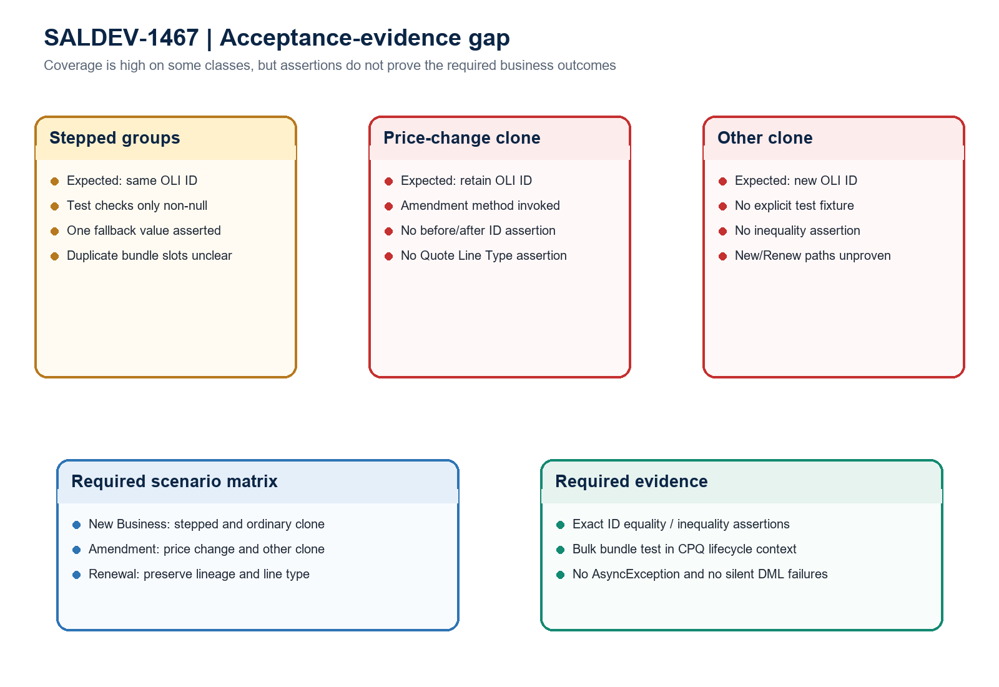
Figure 2. SALDEV-1467 acceptance-evidence gap and required scenario matrix
Architect interpretation: the implementation is not release-ready. Passing tests show executable code, but the failed coverage gate and unchanged cross-object DML pattern leave both deployment and runtime acceptance unresolved.

Required approval gates
Gate | Required action | Owner | Evidence needed
1 | Remove re-entry risk | Developer / CPQ architect | Redesign the OLI-to-Quote-Line sync so the fix does not issue Quote Line DML from OLI after insert in the CPQ transaction.
2 | Clear coverage gates | Developer | Raise QuoteLineTrigger and QuoteLineGroupAsyncHelper to at least 75% in the exact deployment payload.
3 | Assert acceptance rules | Developer / QA | Add exact same-ID and new-ID assertions for stepped, price-change, and ordinary clones across New, Amend, and Renew.
4 | Exercise CPQ scale | CPQ QA | Run representative large bundles and confirm no AsyncException, recursion, SOQL 101, or silent SaveResult failures.
5 | Bound SALDEV-1427 | Product owner / Architect | Document which ramp-ID behavior belongs to SALDEV-1467 versus SALDEV-1427 and deploy/test them as one controlled dependency set.
6 | Revalidate and QA | Release manager / QA | Require a clean 10/10 check-only result, then execute named New/Amend/Renew scenarios with field-level evidence.

Ready-to-paste architect response
STORY COMMENT
Architect review completed for SALDEV-1467 in FlywirePartial. Changes Requested / NO-GO. The original Flow is Obsolete and the scoped Apex compiles, but check-only job 0AfhG000001ZTplSAG failed: all 10 components compiled and all 16 specified test methods passed, yet QuoteLineTrigger is only 69.70% covered and QuoteLineGroupAsyncHelper is 7.69%, below the 75% requirement. More importantly, FWOpportunityLineItemTrigger still runs after insert and OpportunityLineItemTriggerHandler performs Database.update on SBQQ__QuoteLine__c, so the replacement retains the same CPQ after-update re-entry pattern implicated in the original AsyncException. SaveResults are not inspected, one fallback path treats a Quote Line ID as a Quote ID, and the tests do not assert the required same-ID/new-ID outcomes across New, Amendment, and Renewal cloning. Redesign the cross-object sync, fix coverage, add exact lifecycle assertions, clarify the SALDEV-1427 dependency, and repeat check-only plus representative CPQ bundle QA before approval.

Evidence boundary
This assessment uses the SALDEV-1467 ticket text, read-only FlywirePartial identity verification, scoped metadata retrieval, focused Apex tests, source inspection, and a check-only validation. No records, deployment, activation, quick deploy, or org metadata changes were performed.

